**NBTX10442_WEEK-9_LAB-B**

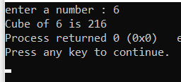Q1. #include<stdio.h>

int cube(int num1)

{

return num1*num1*num1;

}

int main()

{

int num;

printf("enter a number : ");

scanf("%d",&num);

printf("Cube of %d is %d",num,cube(num));

}

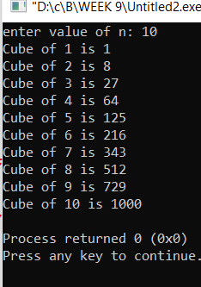Q2. #include<stdio.h>

int cube(int num1)

{

return num1*num1*num1;

}

int main()

{

int num,n;

printf("enter value of n: ");

scanf("%d",&n);

for(int i=1;i<=n;i++)

printf("Cube of %d is %d \n",i,cube(i));

}

Q3. #include<stdio.h>

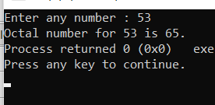

int octal(int decimal)

{

int octal = 0, temp = 1;

while (decimal != 0)

{

octal = octal + (decimal% 8) * temp;

decimal = decimal/ 8;

temp = temp * 10;

}

return octal;

}

int main()

{

int num;

printf("Enter any number : ");

scanf("%d",&num);

printf("Octal number for %d is %d.",num,octal(num));

}

Q4. #include<stdio.h>

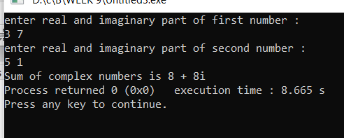

void sum(int r1,int i1,int r2 , int i2)

{

printf("Sum of complex numbers is %d + %di",r1+r2,i1+i2);

}

int main()

{

int r1,i1,r2,i2;

printf("enter real and imaginary part of first number : \n");

scanf("%d%d",&r1,&i1);

printf("enter real and imaginary part of second number : \n");

scanf("%d%d",&r2,&i2);

sum(r1,i1,r2,i2);

}

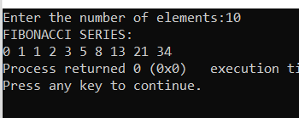Q5. #include<stdio.h>

void fibonacci(int num)

{

int n1=0,n2=1,n3,i;

printf("FIBONACCI SERIES: \n");

printf("%d %d",n1,n2);

for(i=2;i<num;++i)

{

n3=n1+n2;

printf(" %d",n3);

n1=n2;

n2=n3;

}

}

int main()

{

int number;

printf("Enter the number of elements:");

scanf("%d",&number);

fibonacci(number);

return 0;

}

Q6. #include<stdio.h>

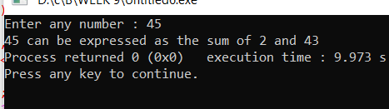void sum(int n)

{

int i,fact,j,a[100],x=0,temp=1;

for(i=1; i<=n; i++)

{

fact=0;

for(j=1; j<=n; j++)

{

if(i%j==0)

fact++;

}

if(fact==2)

{

a[x]=i; //Storing prime numbers upto n

x++;

}

}

for(int i=0;i<x;i++)

{

for (int j=0;j<x;j++)

if(a[i]+a[j]==n)

{

printf("%d can be expressed as the sum of %d and %d",n,a[i],a[j]);

temp=0;

exit(0);

}

}

if(temp==1)

printf("Cannot be expressed");

}

int main()

{

int num;

printf("Enter any number : ");

scanf("%d",&num);

sum(num);

}

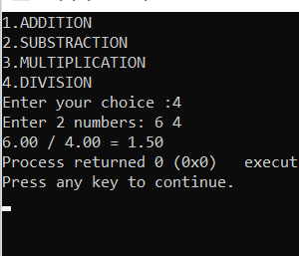

Q7. #include<stdio.h>

void sum(float n1,float n2)

{

printf("%0.2f + %0.2f = %0.2f",n1,n2,n1+n2);

}

void diff(float n1,float n2)

{

printf("%0.2f - %0.2f = %0.2f",n1,n2,n1-n2);

}

void product(float n1,float n2)

{

printf("%0.2f * %0.2f = %0.2f",n1,n2,n1*n2);

}

void quotient(float n1,float n2)

{

printf("%0.2f / %0.2f = %0.2f",n1,n2,n1/n2);

}

int main()

{

int ch;

float num1,num2;

printf("1.ADDITION \n2.SUBSTRACTION \n3.MULTIPLICATION \n4.DIVISION");

printf("\nEnter your choice :");

scanf("%d",&ch);

if(ch>0 && ch<5)

{

printf("Enter 2 numbers: ");

scanf("%f%f",&num1,&num2);

}

switch(ch)

{

case 1:sum(num1,num2);

break;

case 2:diff(num1,num2);

break;

case 3:product(num1,num2);

break;

case 4:quotient(num1,num2);

break;

default:printf(" wrong choice");

}

}